Capacity Reservation with ORM stack

Contents

1. Introduction 3
2. Workflow diagram to deploy the stack 3
3. Create stack for capacity reservation 4
4. Plan the Job 7
5. Apply the Job 8
6. Verify in the Console 9
7. Destroy the stack 12

Introduction

Capacity reservations enable reserve instances in advance so that the capacity is available for workloads when need it. Capacity reservations provide the following benefits:
- Assurance that customer have the capacity necessary to manage their workload. Reserved capacity is available for customers tenancy to consume at any time.
- No size or time commitments. Create a reservation with as little or as much capacity as customers need, and delete the reservation at any time to stop paying for it.
Prerequisites:
- Select the shape to use for instances created against this capacity configuration. If you select a flexible shape, enter values for Cores and Memory (GB).
- Select the shape associated with this capacity configuration. Each shape and fault domain combination must be unique within the capacity reservation.

Workflow diagram to deploy the stack

Below diagram shows how the Terraform Artifact are applied in the OCI. While creating a ORM stack, using terraform deliverables Init, Plan and Apply is the flow to provision the resource in the OCI. We can have the deliverables in any of below.

- GitLab/GitHub Repo
- Bitbucket
- Can be in folder/.zip in the local disk
- Object Storage Bucket
- Can be in compartment
- Oracle provided Template


Create stack for capacity reservation

Go to OCI Console Developer Services Resource Manager Stacks select the compartment Create Stack

My Configuration Folder Browse Select the “capacity_reservation” folder that contains the terraform Upload

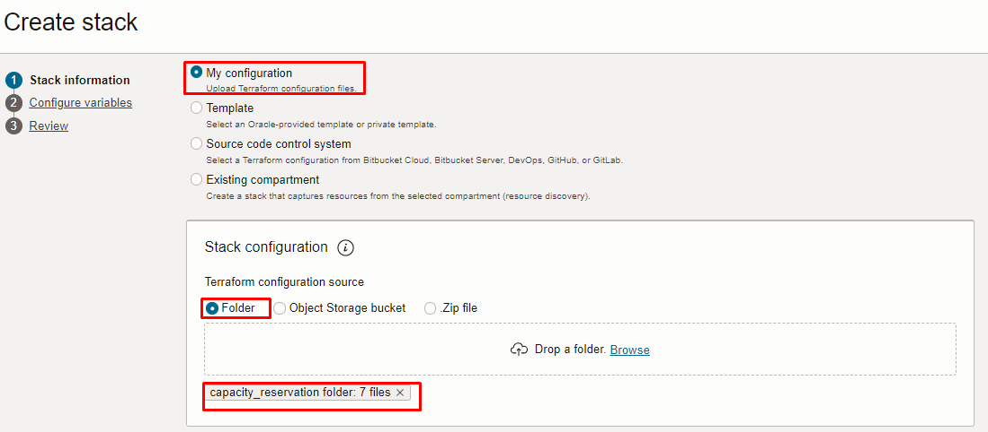
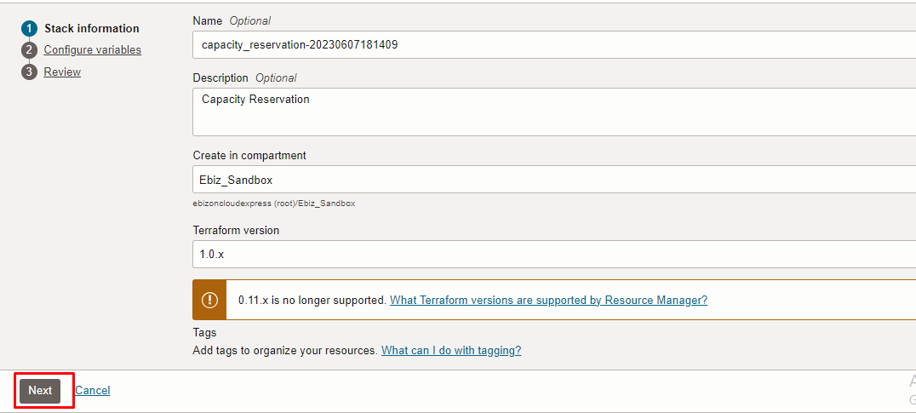
Click “NEXT”

Select the parameters as per the below screen,
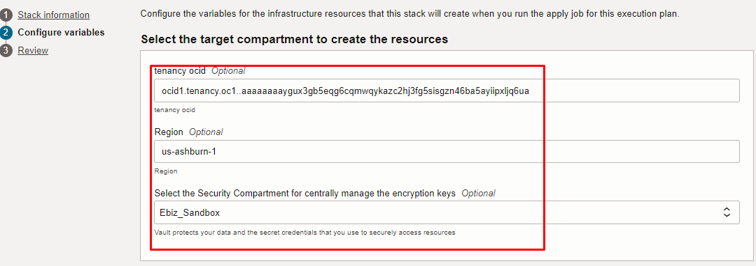
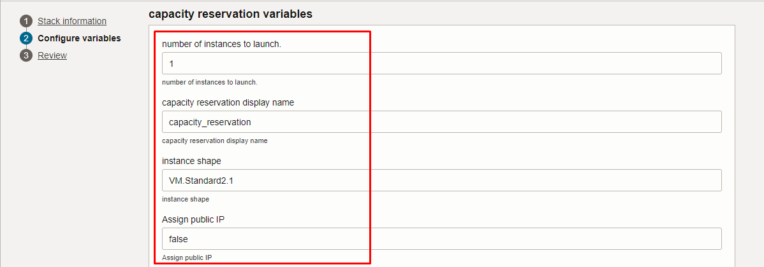
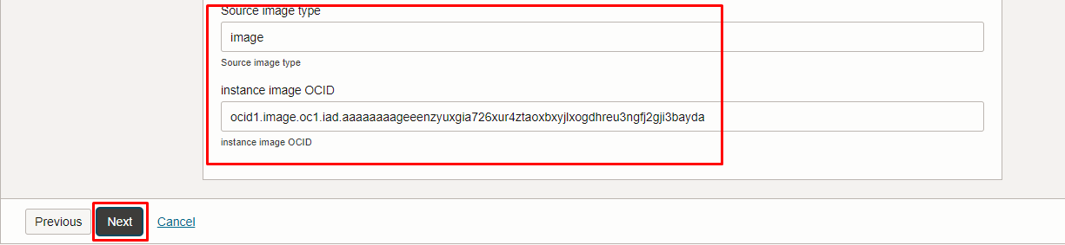
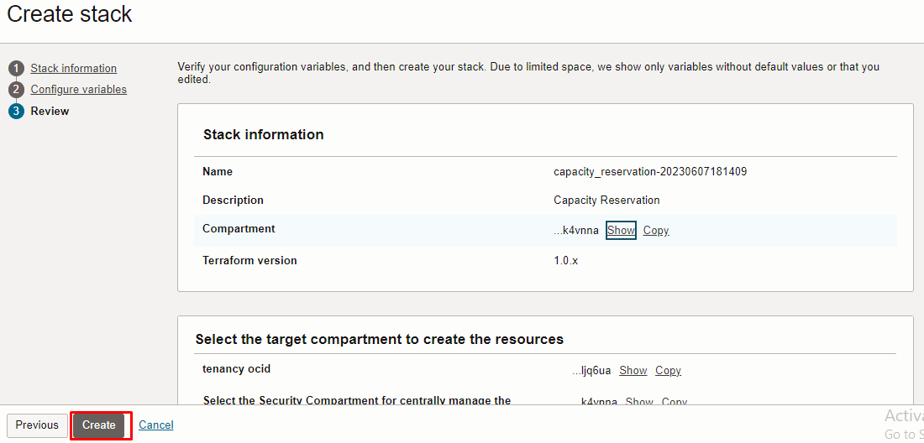
Click “NEXT” Click “CREATE”

Plan the Job

Click the “Plan”

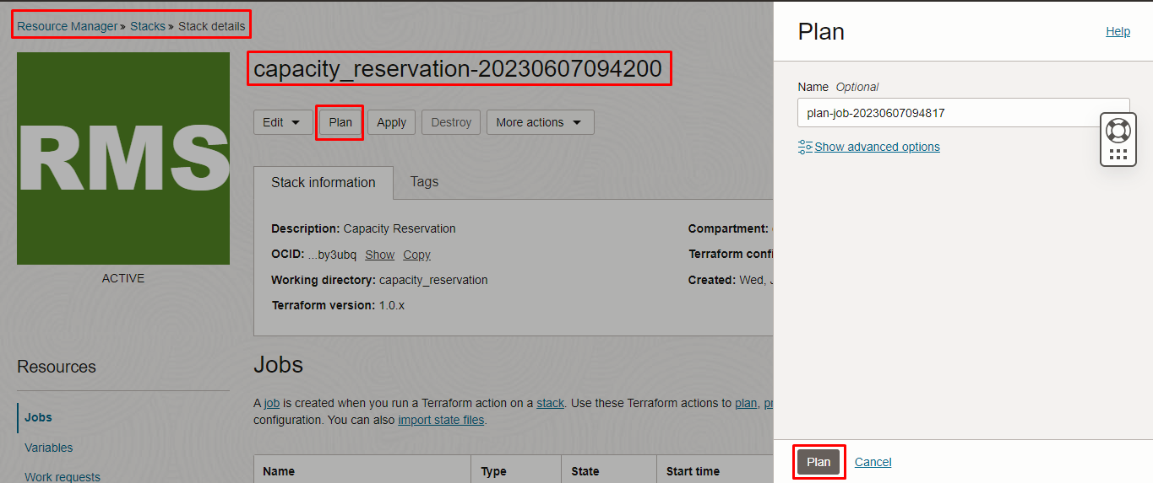
Verify the Plan is successful.
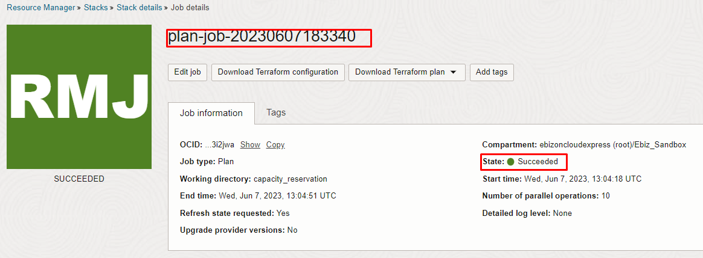
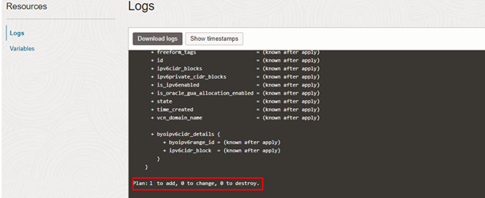

Apply the Job

Once the “plan” is success, now click “Apply”

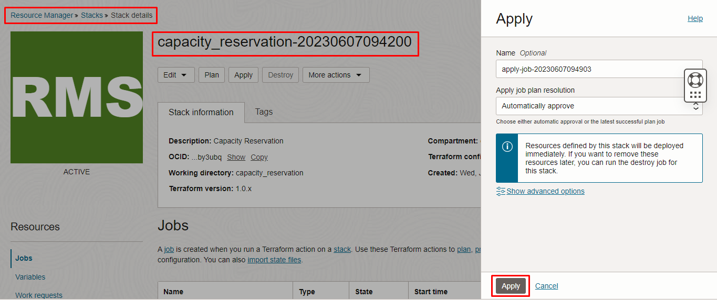

Verify the Apply is successful.

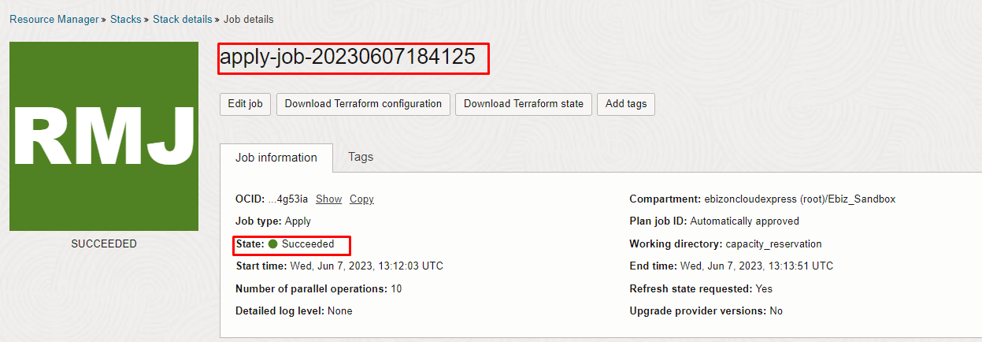

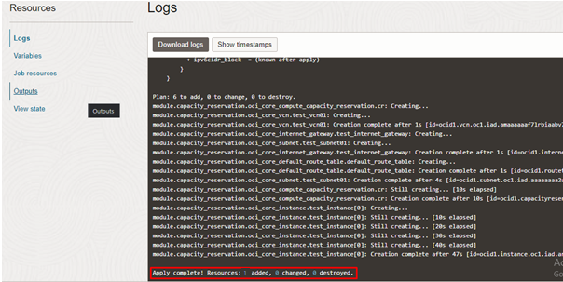

Verify in the Console

Go to OCI Console Compute Capacity Reservation

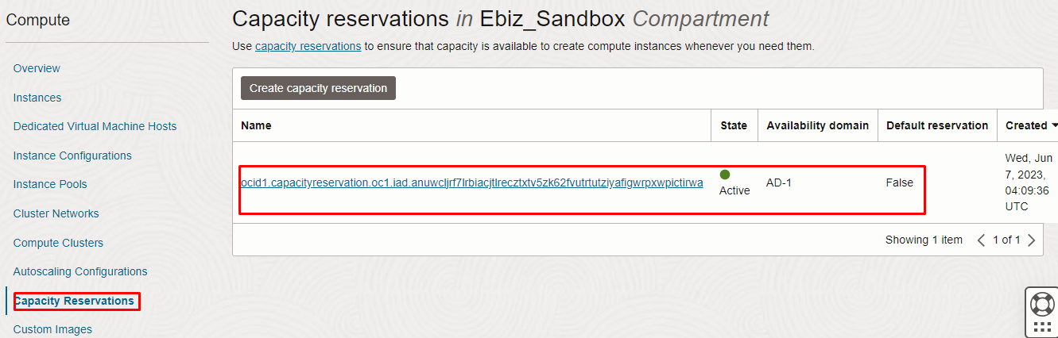
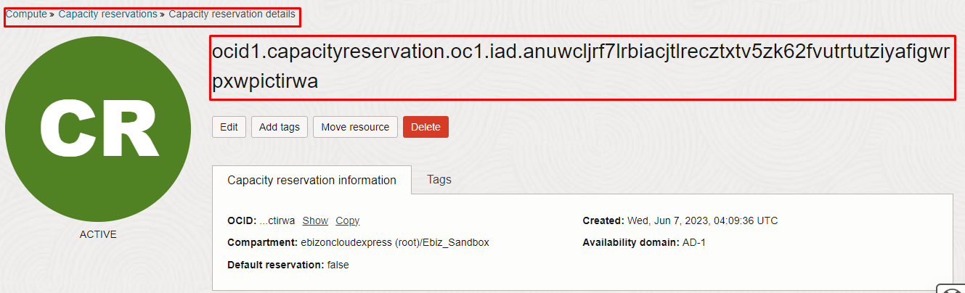

Destroy the stack

Create a destroy job in Resource Manager to release resources associated with a stack and clean up the tenancy. Once destroyed data cannot be recovered from resources.

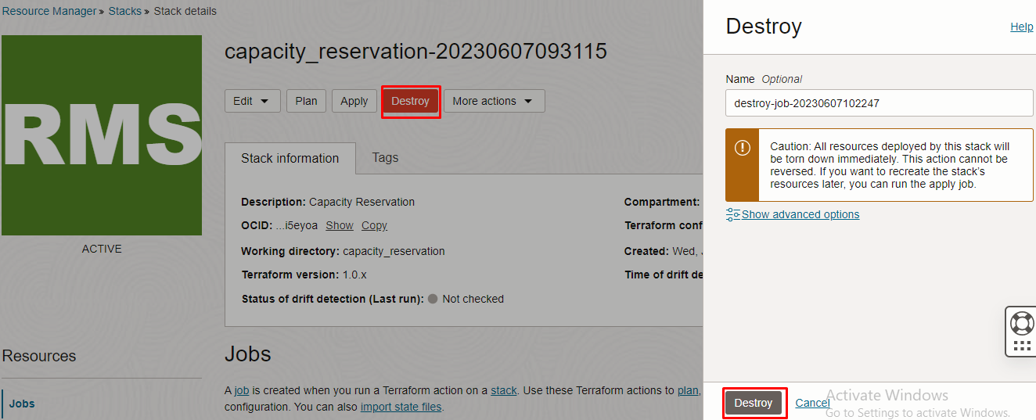#########END#########

